International Business Management
1st Seminar Work
why should companies go international? Leadership or management? Organisational culture
Judit Galambos/David Parker

TASK 1 – Case study solution
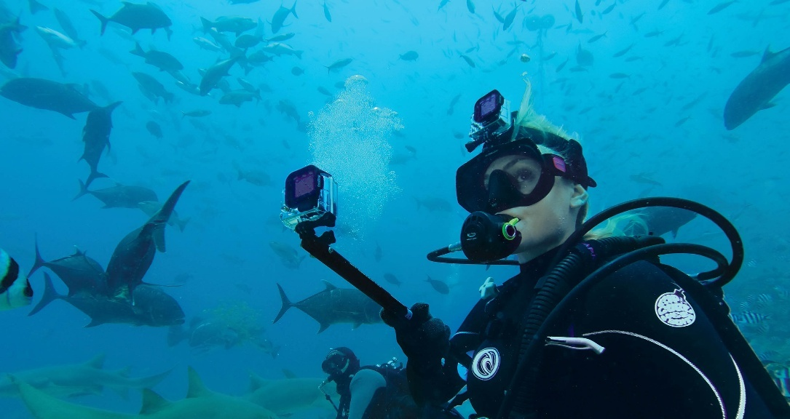
Capturing the World: How GoPro Went Global
When small companies go international, it often starts with a simple idea that turns out to have worldwide appeal. That is exactly what happened with GoPro. What began as a passion project eventually became a global brand, thanks to smart expansion and constant innovation.
How It All Started
GoPro was founded in 2002 by Nick Woodman, a surfer who wanted a better way to film himself and his friends in action. At the time, there was no affordable, tough camera designed specifically for athletes. So, he decided to create one as he says, “Before GoPro, if you wanted to have any footage of yourself doing anything, whether it’s video or photo, you not only needed a camera, you needed another human being…”.

In the early days, the company operated on a small budget and focused on producing compact, durable cameras that could handle extreme sports. The brand quickly connected with surfers, skiers, cyclists, and other adventure enthusiasts. GoPro was not just selling a camera; it was selling a lifestyle built around adventure and sharing experiences.
It did not take long for people outside the United States to notice. The appeal of action sports and self-expression was not limited to one country, and international demand began to grow. Nick credits much of this growth to users for posting videos of their experiences online “Somebody captures an incredible video, shares it online, and inspires millions of other people to go and do the same with their GoPros, and then it happens again and again…”
Expanding Internationally
Going global was not just an opportunity—it became essential for growth. The market for action sports was worldwide, and limiting sales to the U.S. would have restricted the company’s potential.
GoPro’s message of exploration and creativity resonated across borders. As interest increased in Europe, Asia, and other regions, international sales became a major source of revenue. Within a few years, a large share of the company’s income came from outside the United States. International markets were no longer secondary; they were central to the company’s success.
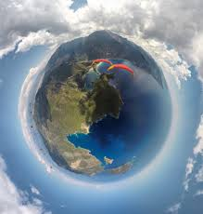
The Challenges of Going Global
However, expanding internationally was not without difficulties.
Competition increased quickly. Large electronics companies and lower-cost manufacturers introduced similar products, which pushed prices down and reduced profit margins. Copycat products also became a concern.
Manufacturing mainly took place in Asia, which created supply chain challenges. Managing quality across different markets required strong oversight. In addition, relying on overseas production exposed the company to currency fluctuations and geopolitical risks.
Exchange rates also affected profitability. As more revenue came from abroad, changes in currency values had a noticeable impact on financial results.
Another major challenge came from technology itself. Smartphone cameras improved rapidly, reducing the need for separate action cameras. GoPro had to rethink how to stay relevant in a changing market.
The response
To remain competitive in an increasingly crowded market, GoPro intensified its investment in research and development. The company consistently introduced enhanced features, improved image quality, and more advanced models in order to differentiate itself from lower-priced competitors and imitation products.
At the same time, GoPro strengthened its international distribution strategy. It developed partnerships with retailers across multiple regions while expanding its direct-to-consumer online channels. This blended approach increased global reach, improved brand visibility, and allowed the company to engage more directly with customers in diverse markets.
Recognising the risks of relying solely on hardware sales, GoPro broadened its strategic focus. The firm expanded into software and subscription-based services, offering customers integrated tools for editing, managing, and sharing content. The aim was to build a comprehensive ecosystem rather than simply sell a device.
As founder Nick Woodman explained:
“Every year we see different companies with GoPro-like offerings. Pretty much everybody else is just making hardware—they are making a cold, hard thing. They are not creating an experience or an end-to-end solution like we are at GoPro.”
This perspective highlights the company’s shift from being a hardware manufacturer to positioning itself as a provider of a complete user experience—an approach designed to sustain competitive advantage in global markets.
Key Takeaways
GoPro’s experience highlights several important lessons about international business. Expanding abroad can drive significant growth, especially when a product has universal appeal. At the same time, global markets bring added complexity—competition, regulatory differences, currency risks, and fast-changing technology.
Most importantly, the story shows that international success requires flexibility and constant innovation. A strong brand may open doors worldwide but maintaining that position demands ongoing adaptation.

Answer the following questions in small groups. Please give as much detail as possible.
1. What unmet market need led to the founding of GoPro?
2. How did GoPro create value beyond simply selling a product?
3. Why did international expansion become essential rather than optional for GoPro?
4. What role did user-generated content play in GoPro’s international growth?
5. Identify and explain two major challenges GoPro faced in its international operations.
6. In what way did technological change threaten GoPro’s competitive position?
7. How did GoPro respond strategically to intensifying global competition?
8. What international distribution strategies did GoPro implement to strengthen its global presence?

TASK 2 – Management
Discuss in small groups and prepare answers to share with group.

- To what extent is effective management something you are born with as opposed to a set of skills that can be taught?
- What makes a good manager?

TASK 3 – Management
Read the following article and write a brief summary of Drucker’s five tasks. When you have finished compare your summary with the group.
What is management?

Management is important. The success or failure of companies, public sector institutions and services, not-for profit organizations, sports teams, and so on, often depends on the quality of their managers. But what do managers do? One well-known classification of the tasks of a manager comes from Peter Drucker. Drucker was an American business professor and consultant who is often called things like ‘The Father of Modern Management’.
Drucker suggested that the work of a manager can be divided into five tasks: planning (setting objectives), organizing, integrating (motivating and communicating), measuring performance, and developing people.
First of all, senior managers and directors set objectives and decide how their organization can achieve or accomplish them. This involves developing strategies, plans and precise tactics, and allocating resources of people and money.
Secondly, managers organize. They analyse and classify the activities of the organization and the relations among them. They divide the work into manageable activities and then into individual tasks. They select people to perform these tasks.
Thirdly, managers practise the social skills of motivation and communication. They also have to communicate objectives to the people responsible for attaining them. They have to make the people who are responsible for performing individual tasks form teams. They make decisions about pay and promotion. As well as organizing and supervising the work of their subordinates, they have to work with people in other areas and functions.
Fourthly, managers have to measure the performance of their staff, to see whether the objectives or targets set for the organization as a whole and for each individual member of it are being achieved.
Lastly, managers develop people – both their subordinates and themselves. A company’s top managers also have to consider the future, and modify or change the organization’s objectives when necessary, and introduce the innovations that will allow the business to continue. Top managers also have to manage a business’s relations with customers, suppliers, distributors, bankers, investors, neighbouring communities, public authorities, and so on, as well as deal with any crisis that arises.
Although the tasks of a manager can be analysed and classified in this fashion, management is not entirely scientific. There are management skills that have to be learnt, but management is also a human skill. Some people are good at it, and others are not. Some people will be unable to put management techniques into practice. Others will have lots of technique, but few good ideas. Excellent managers are quite rare.

TASK 4 – Management vs Leadership
Sinek Comprehension Questions
- What two personal qualities does the speaker argue are most essential for effective leadership, and why are they important?
- According to the video’s message, why do many individuals become managers but not leaders?
- What distinction does the speaker make between being responsible for a job and being responsible for people?
- What does the speaker claim about the responsibility of leaders in relation to results?
- Why might some people never become leaders even if they hold managerial positions, according to the message?

TASK 5 Discussion - How can organisations better prepare technical experts for leadership roles?
Create a bullet point plan

Task 6 Seth Godin
  - How does the speaker distinguish between management and leadership?
  - Why does the speaker argue that leadership is about making a difference?
  - What role does responsibility play in leadership, according to the speaker?
  - Why is leadership not limited to people with formal authority?
  - How does fear affect leadership behaviour?

  - What does the speaker suggest organisations need more of: managers or leaders? Why?

Task 7 discussion When is it preferable to have a manager rather than a leader?

Task 8 Leadership and organisational culture
- Steve Jobs introduced in 2007 the first generation of Iphone. The technology itself, has been revolutionary. The speech that he delivered is also one of the most memorable, most watched performances of him.
- Please watch the video, and answer the question: how was the corporate culture of Apple at that time? (Students can add their own knowledge of Jobs to the answer)
https://www.youtube.com/watch?v=x7qPAY9JqE4

